Brief – Networked Resource Management

**What it is:**

It’s a modular networked resource management system that will be easy to implement by a developer, the system will be split into multiple subsystems in the form of components and scripts that the developer can pick and choose to use from, all the developer has to do is add the subsystems to the game object they want to have that functionality and set up the variables in the inspector.

This can be used for developing online and offline City Builders and Colony Sims, like SimCity, Cities: Skylines, Banished, and Patron. The package will contain pre-made subsystems including a Resource Attribute and Management System, a Resource Node System, and Networking systems the developer can use to speed up their workflow by removing the need to spend time developing these systems themselves, this will allow the developer to integrate their unique systems and the other game mechanics into their game, fast tracking their development cycle.

**Third party libraries:**

**Mirror v66.0.9:**

License: Extension Asset

Mirror is a high level networking API for Unity, supporting different low level Transports. It’s included in the system to take care of the majority of the networking side of the system.

**What will be contained in the Resource Management part:**

This outlines the resources and components that will be contained within the Resource Management System and the variables in them.

* Food:
* Random spawning vegetation
* Farming food
* Whether or not it respawns over time
* Variables:
* Rate of growth (float)
* Food resource produced (enum)
* Amount of resource obtained (float)
* How much Hunger and Thirst it restores (float)
* Time it takes to harvest (float)
* What tool is used to harvest (enum)
* Water:
* Well– A well will be a placeable building that can be used to collect drinking water. Space is pre-defined.
* Bodyofwater – A definable area of water that can represent lakes and rivers, these can be used to collect drinking water. Space is definable.
* Variables:
  + Is it clean/safe (bool)
  + Is it depletable (bool)
  + How much water is left (float)
  + Does it refill (bool)
  + Time it takes to refill (float)
  + How much thirst does it restore (float)
  + Time it takes to harvest (float)
  + Resource produced (enum)
  + What tool is used to harvest (enum)
* Customisable resource nodes:
* Does it spawn is clusters or by itself (bool)
* How spread apart the nodes are (float)
* How rare it is (float)
* Is it farmable (bool)
* Is it plantable (bool)
* Rate it grows at (if viable) (float)
* Time it takes to harvest (float)
* What resource it is / what resource it drops (enum)
* How much of that resource it drops (float)
* How depleted it is (if viable) (float)
* What tool is used to harvest (enum)
* If it auto respawns (bool)
* If desirable, can inherit functionality from food and/or water. For the functionality that overlaps, the version of the variable in the Custom Node will be used, the version in the duplicated functionality will be discarded.
* Storage
* What resources can it store
* Are the resources visualised on/in it
* The model/s the visualised resources will use
* How many resources it can hold

**Mathematical equations:**

A combination of basic addition, subtraction, division, and multiplication will be used in most functions.

The constant rate of decay will just use a lerp function **(a + (b – a) * t)** and **t** will be equal to the **current accumulated time** divided by the **maximum amount of time** **(t = time / max time)**.

When adding resources to the storage, there will be an equation to increase the time of decay **((number of resources + amount to add) / max amount of resources * max time)** since time controls how many resources there are.

Nodes that grow will use the same lerp function **(a + (b – a) * t)** as the constant rate of decay, using **t** as a percentage of its life cycle to control the max yield that resource can produce using logic to determine when during that life cycle the resources able to be gained will drop off.

**How the systems will be modular:**

**Networking:**

A send and receive data component will be used along side Mirrors networking components for sending and receiving data from other scripts on the game object it’s attached to between the client and the server.

There will be three other components that will handle what to do when there’s no response from the client or server, an unexpected response from the client or server, and when an impossible action comes from a client.

**Resource Attribute System:**

A scriptable object will be used to create the resources and their attributes as two separate list.

The resources and attributes will be accessible from other components and scripts.

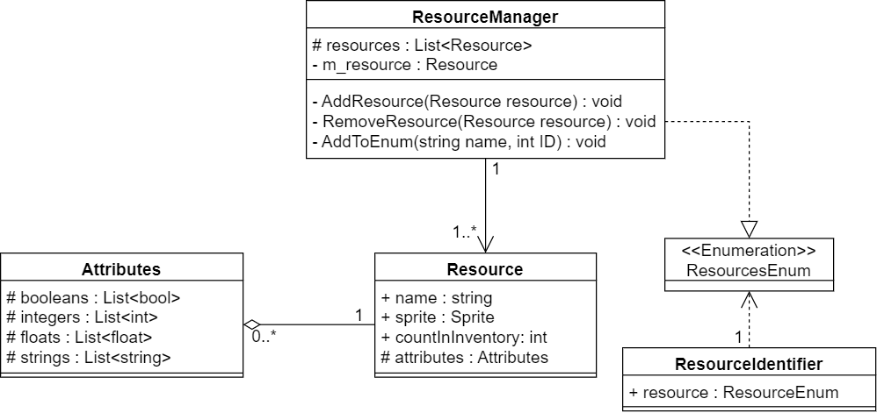

**Collection Attribute System:**

A similar system to the Resource Attribute System will be implemented for creating a Collection Attribute System using a scriptable object with the collection methods and the attributes being split into two separate lists.

The collection methods and attributes will be accessible from other components and scripts.

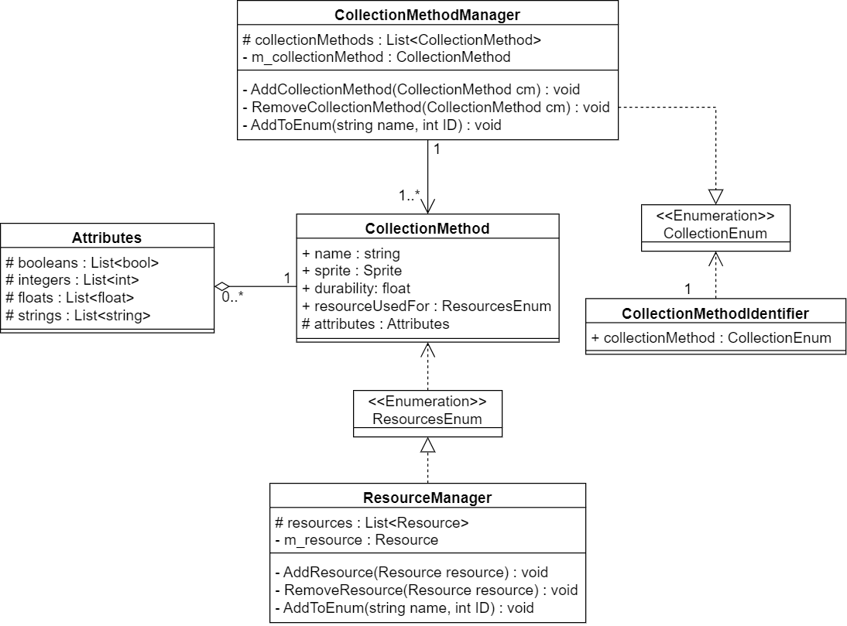

**Resource Nodes:**

The resource node will be a component that can be added to a game object and will hold information that will control how that resource node interacts with the world and the player, the information it will hold is listed as follows:

* Does it spawn is clusters or by itself (bool)
* How spread apart the nodes are (float)
* How rare it is (float)
* Is it farmable (bool)
* Is it plantable (bool)
* Rate it grows at (if viable) (float)
* Time it takes to harvest (float)
* What resource it is / what resource it drops (enum)
* How much of that resource it drops (float)
* How depleted it is (if viable) (float)
* What tool is used to harvest (enum)
* If it auto respawns (bool)

There will also be an option inherit variables from Food and Water resources and to add custom variables to the resource node, the developer will have to script in what the custom variables do.

**Storage Nodes:**

The Storage Node will contain a list of the resources and collection methods with the amount of each item. Storage Nodes will contain public getters and setters accessible from scripts allowing the developer to get and set the number of a specified item in each Storage Node.

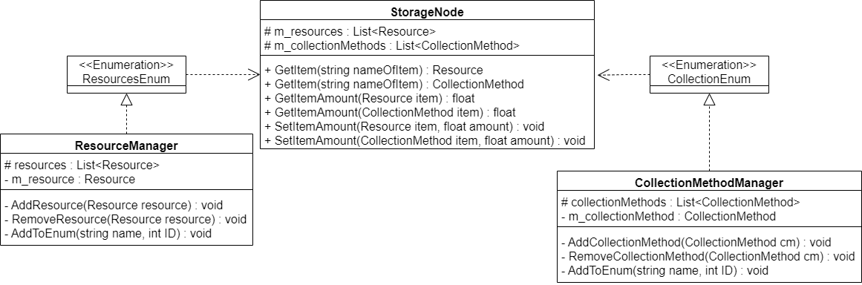

**How it will be integrated:**

The system will be a unity package downloadable from the asset store, when added to the project, the developer will import the package.

To define resources and collection methods and the attributes for both, the developer will be able to create two separate scriptable objects, a Resource Manager and a Collection Method Manager. In these scriptable objects there will be two lists, one for the resources or collection methods and one for the attributes, all resources will share the same attributes and all collection methods will share the same attributes.

A Resource Node component will be able to be added to game objects for the Resource Management System to recognise that object as a node for a specific resource. Resource Nodes contain information on how the world and the player can interact with the Resource Node and what is obtained from it once harvested.

A Storage Node component will be able to be added to a game object for the Resource Management system to recognise that object as a Storage Node to store resources in. The information of how much of each resource will be accessible from scripts allowing the developer to create custom usages for the Storage Node if desired.

Networking for the Resource Management System will use a component that can be added to a game object that will contain two lists, one holding names of scripts to be used and another holding names of variables in those scripts to be used. The developer will fill the lists with the names of the scripts and variables in the parent game object, the variables will be sent between the client and server using the KCP UDP communication protocol.